Prototype

This is a prototype and does not represent final software quality. Elements, layouts and colours may be changed later.

The learning process is divided into 5 parts: **Tutorial**, **Procedure**, **Efficiency**, **Correctness** and **Exercise**. Due to lack of space, we mainly focus on **Procedure**.

In the following figures, the **grey modules** are expected to be images or animations (like GIFs), or represent the inside it is an entirety, and the **sky blue round with numbers**, is helping explain what the object nearest to it does, when the first time it shows. They will be described as (n) in main text.

In our design, each part has a different **representative colour**, **Tutorial** pink, **Procedure** blue, **Efficiency** green, **Correctness** red and **Exercise** orange. This helps user quickly distinguish which learning part they are in.

When the software is firstly opened, it will ask if the user is completely a beginner and want to have a beginner level **Tutorial**. We prepare basic algorithms and other simple topics, helping users gain initiate knowledge about algorithms. If the user selected he/she is not complete beginner, he/she will skip this part, but can go back to this later.

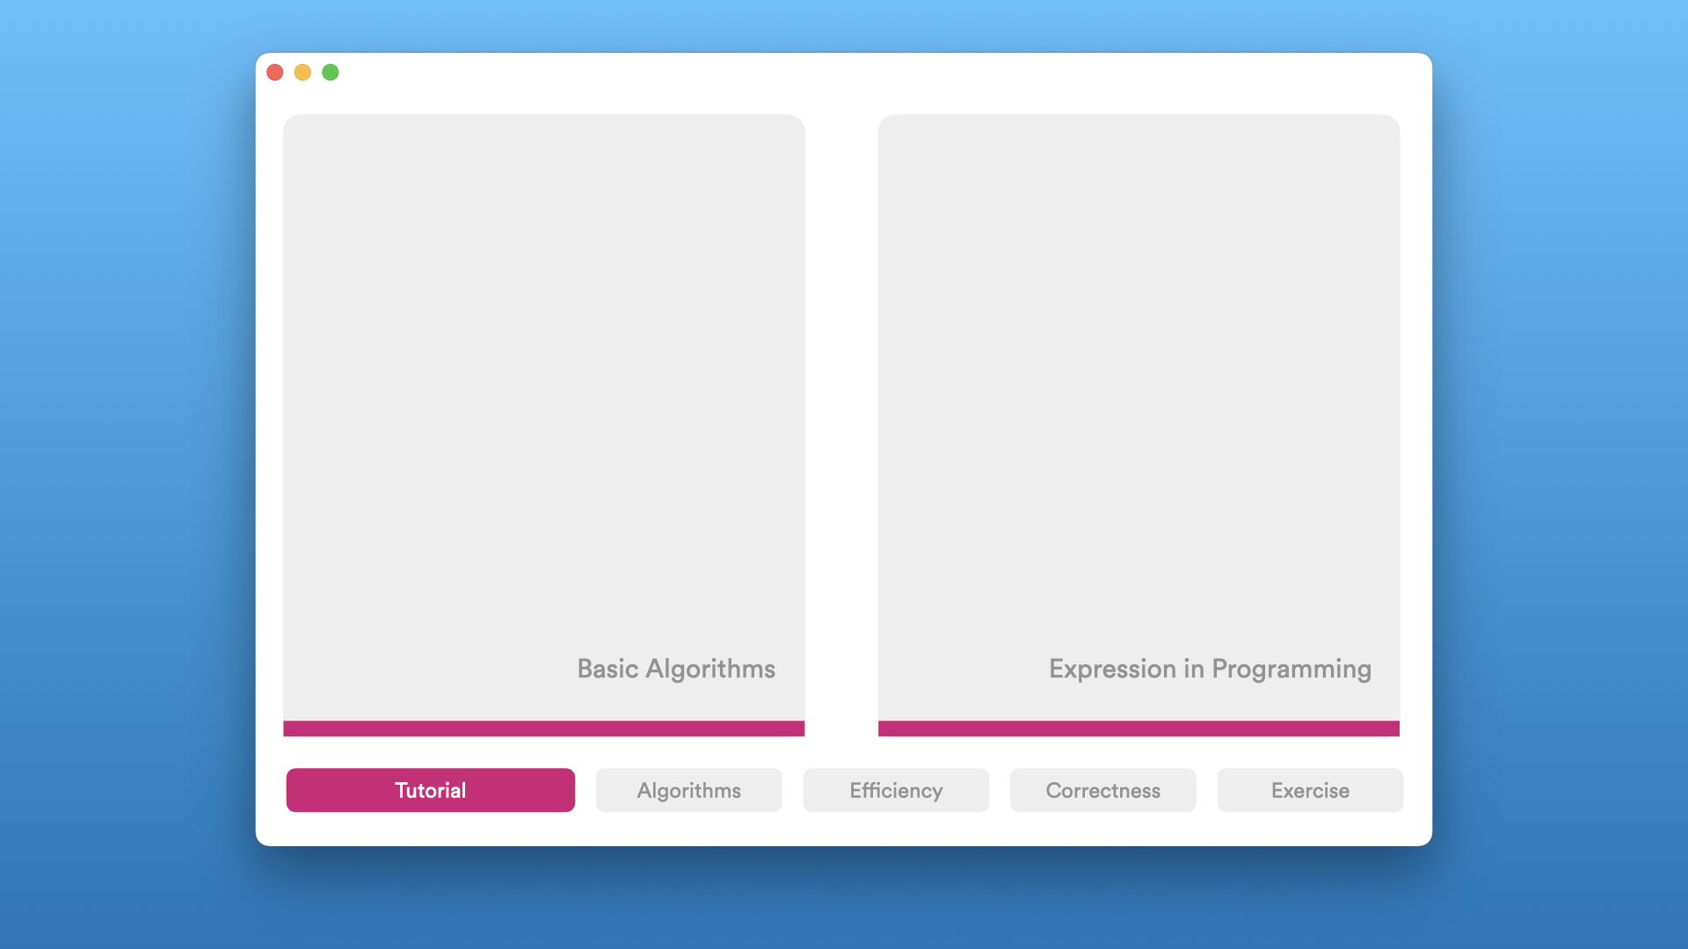

Figure 1. Tutorial page

Below are the main pages of **Procedure**, **Efficiency** and **Correctness** parts. Take **Procedure** part for example. (1) is an **algorithm block** to be learn. User is able to click it to enter the following learning process of this algorithm. Every (2) below the (1) algorithm block, is a progress bar, showing the percentage user have learnt in this module. Two buttons at (4) are settings and help, user may set language, volume, export notes of sorting algorithms to a file, share this software and give feedback to the developers in the setting page, or get help about how to use this software in the help page. (5) is a menu to switch between **parts**.

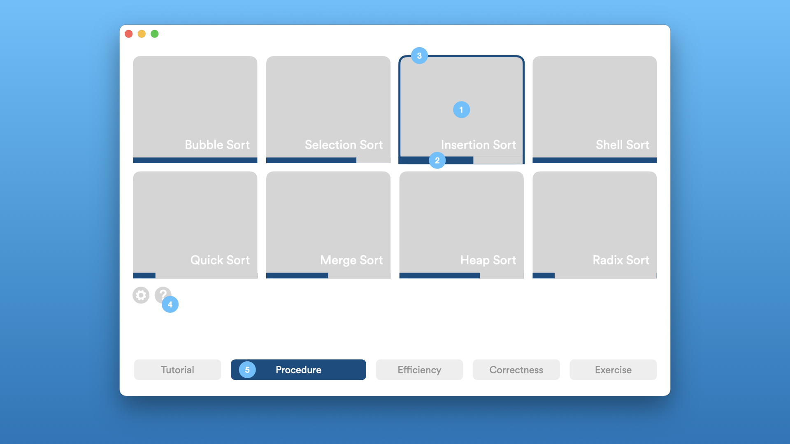

Figure 2. Procedure main page

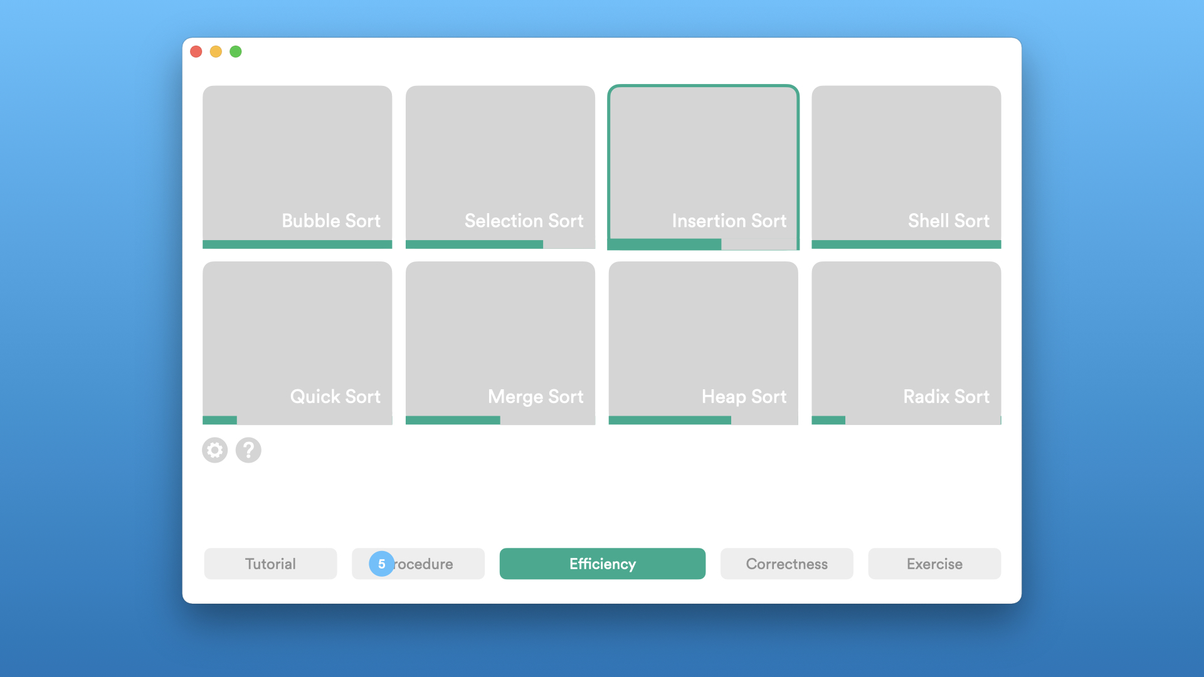

Figure 3. Efficiency main page

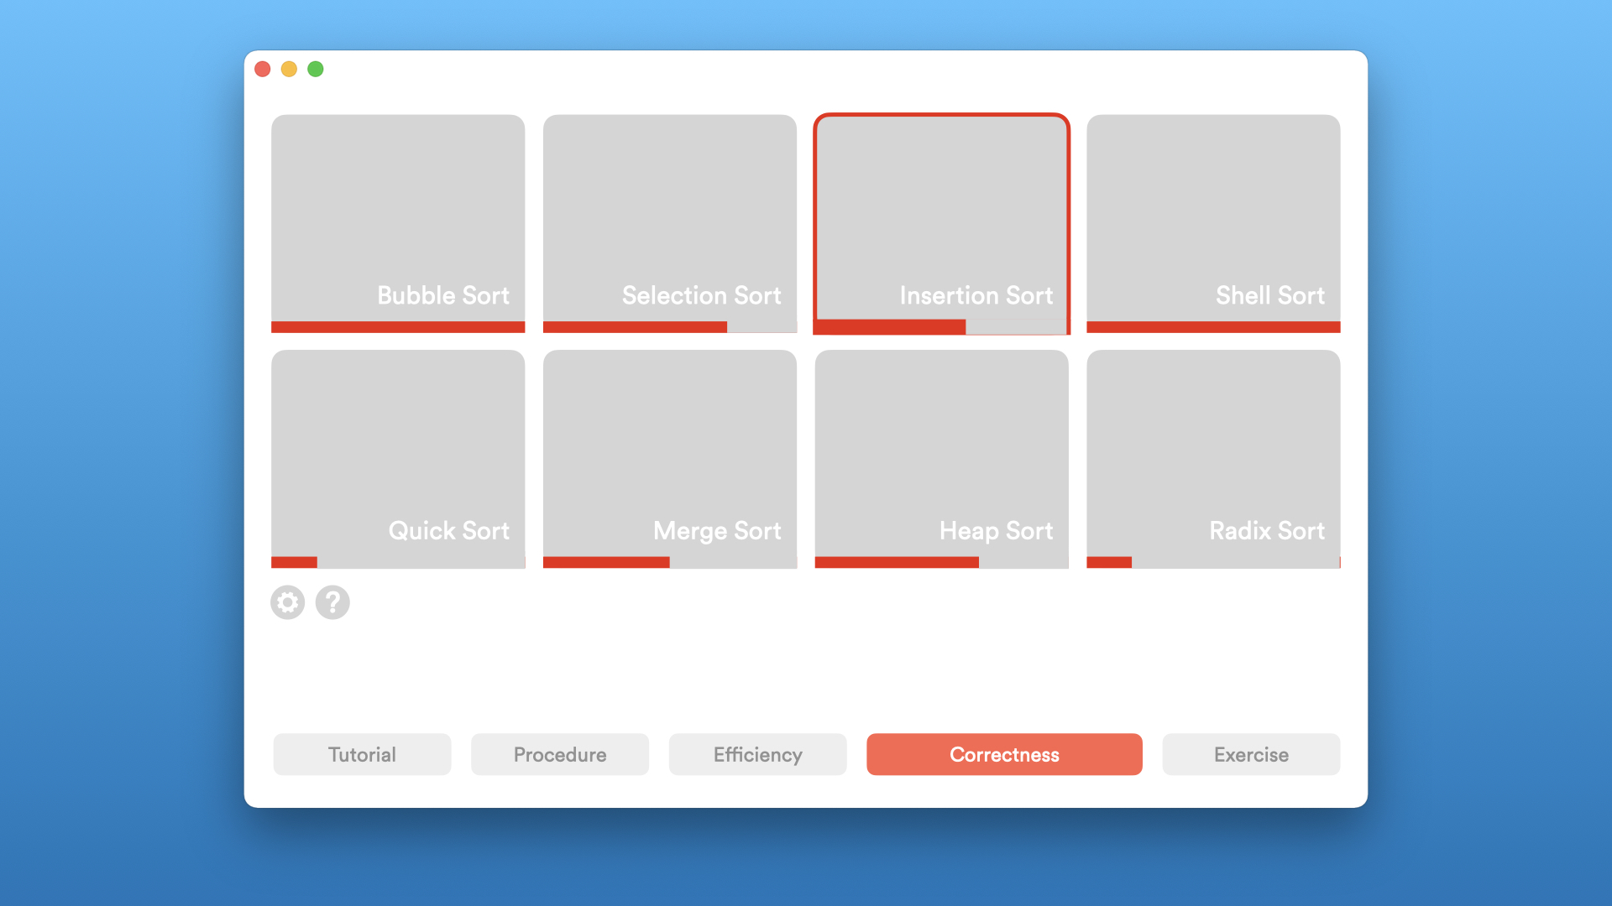

Figure 4. Correctness main page

When the user clicks an **algorithm block** in **Procedure** part, he/she will enter the **Procedure** part of this algorithm. The algorithm is divided into 4 subparts: Introduction, Operation, Implementation and Exercise.

Take bubble sort for example.

The figure below is the first subpart of **Procedure**, Introduction. (1) is the home button, when pressed the software will back to menu and save current progress. (2), (3) and (4) is used to switch between subparts. (2) and (4) will move back and front, and when (3) is clicked, a drop-down box will show all subpart, and the user may jump to the subpart he/she likes. (5) is description text, which would appear often in this software. (6) is the preset auto-playing animation. Each bar is an element, and the whole bunch of elements is the array to be sorted. For simplification, we will call all these thing **visualiser** in the following text. The animation will show how this algorithm works. The user is not allowed to operate it currently. He/she is expected to watch it playing, together with the (5) description on the left, to get a general idea about this sorting algorithm.

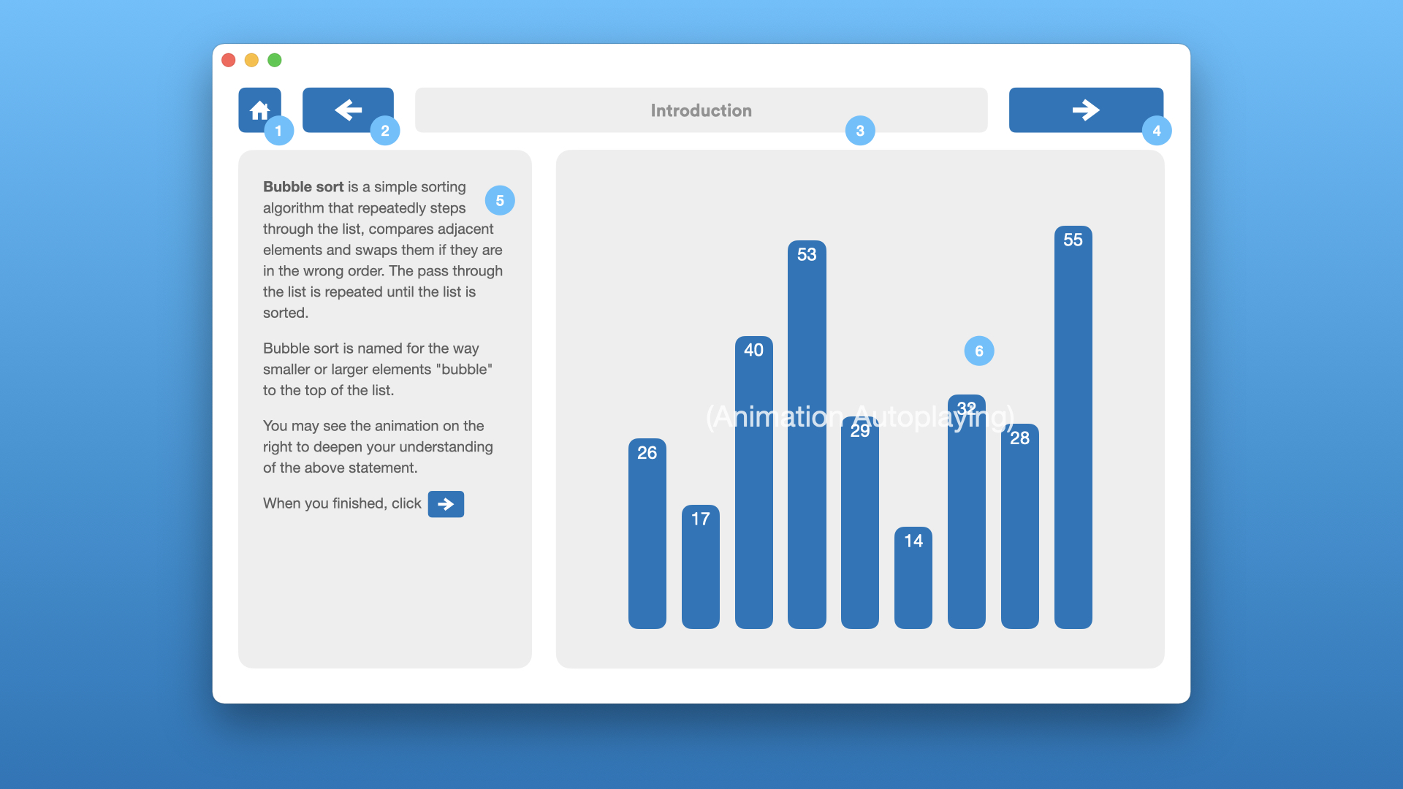

Figure 5. Procedure - Introduction

If the user clicks the next button, he/she will go to the Operation subpart. Here the user is able to play with the **visualiser**, that is, he/she can now edit the value of each element, add or delete value, play or pause the process, go to next step or previous step.

Below figure is the second subpart of **Procedure**, Operation. The visualiser, but now editable. When the user clicks an element’s value on the top in position (1), he/she will be able to edit the value; when the user clicks an element’s tail at the bottom in position (2), a minus symbol will show and he/she will be able to delete this element. If the user put cursor at the very right of the last element, an addition symbol “+” Below this visualiser there is a (3) explanation text, saying what is current step doing. (4) is a progress bar of the sorting process; user may drag the dot to move forward and backward. Below buttons are able to move one step backward, play automatically or pause, and move one step forward.

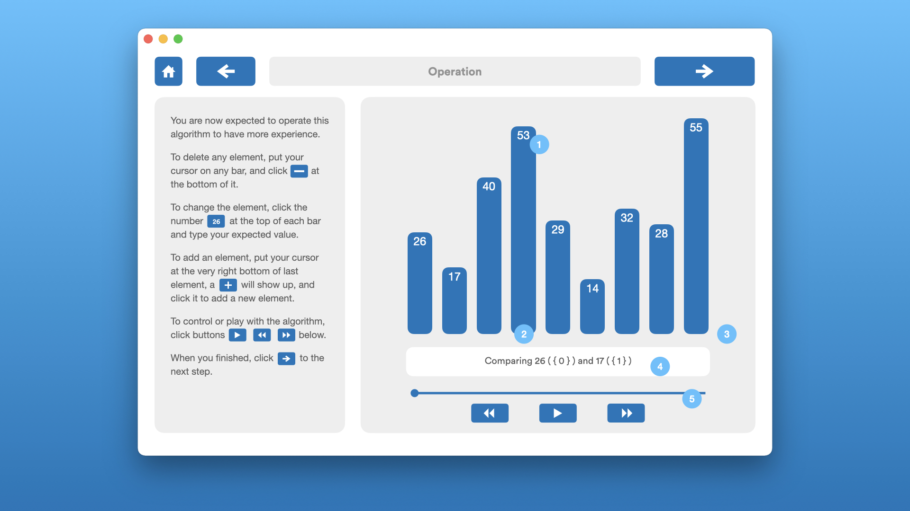

Figure 6. Procedure - Operation

If the user clicks next button, he/she will go to Implementation subpart. Here user is able to implement the algorithm using our **building blocks**, a simplified and more user-friendly method to some extent.

Below figure is the third subpart of **Procedure**, Implementation. In building blocks box in (1), there are building blocks which can be dragged to the (2) coding module, add expressions, to implement the algorithm. The user can click buttons in (4), to control, run and stop the algorithm. Whenever the building blocks are changed, the visualiser will automatically reset.

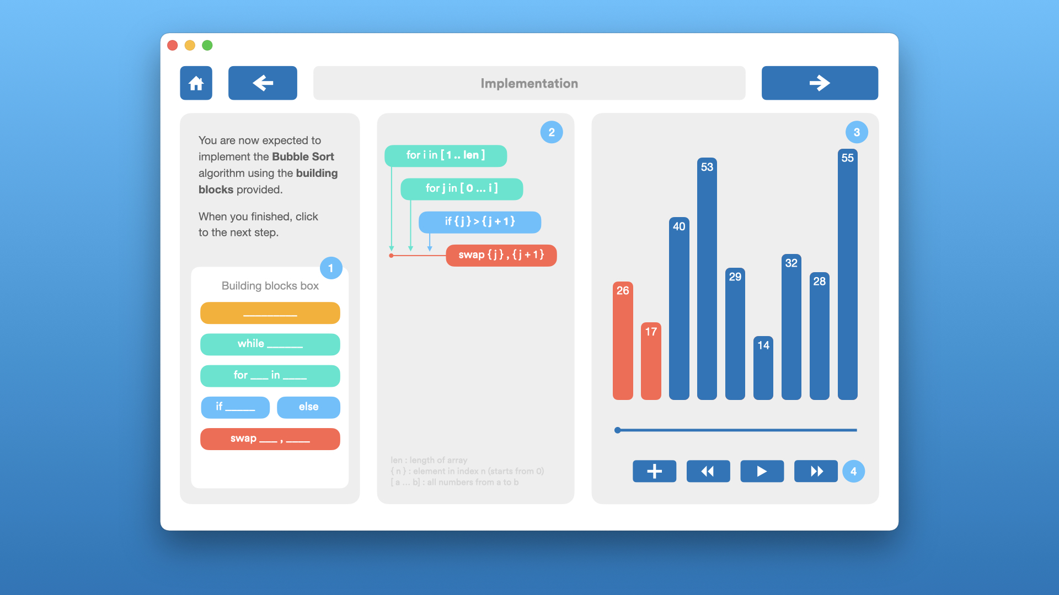

Figure 7. Procedure - Implementation

A congratulation message box will show up when the user successfully finished an algorithm in a part. In below diagram, take Implementation part for example.

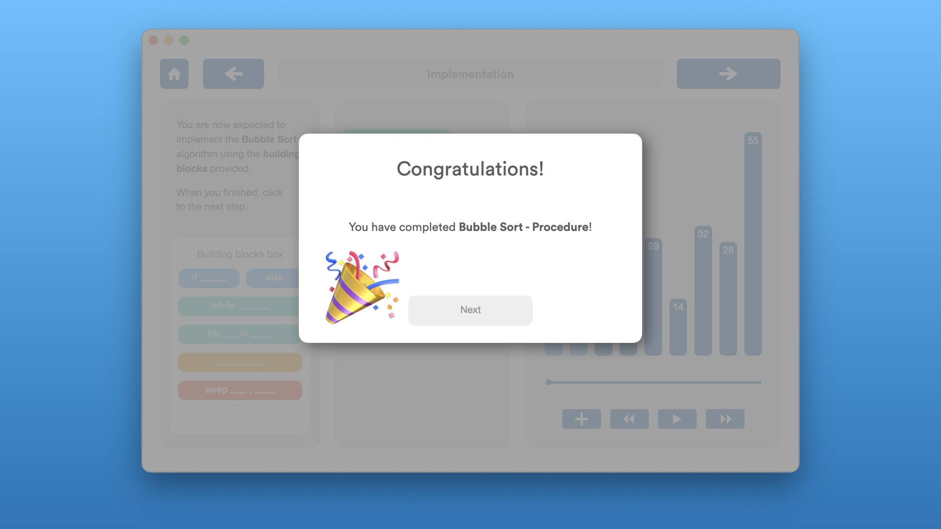

Figure 8. Congratulation

For **Efficiency** part, the user will firstly be given an introduction to efficiency, time complexity, and then choose multiple different algorithms to compare and run together as array length go to infinity, to recognise basic knowledge about it.

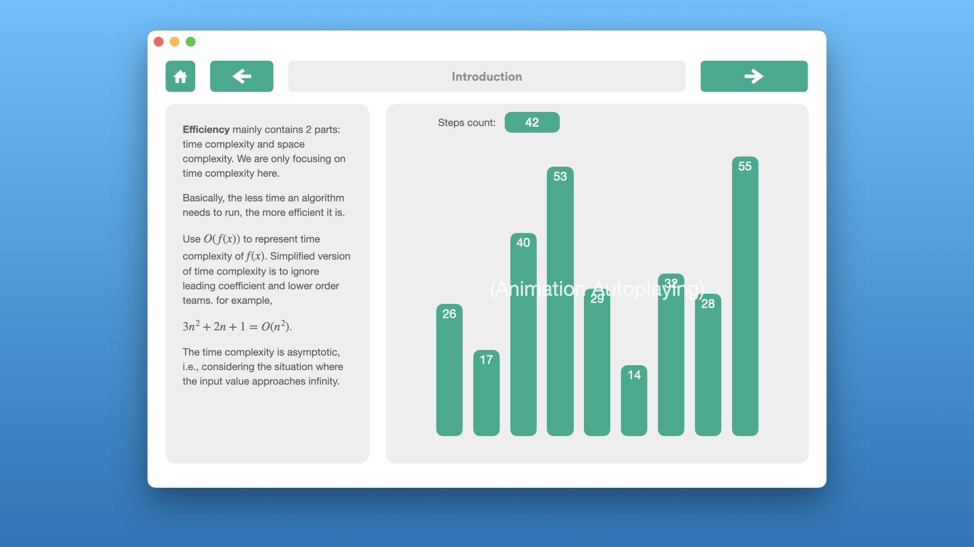

Figure 9. Efficiency - Introduction

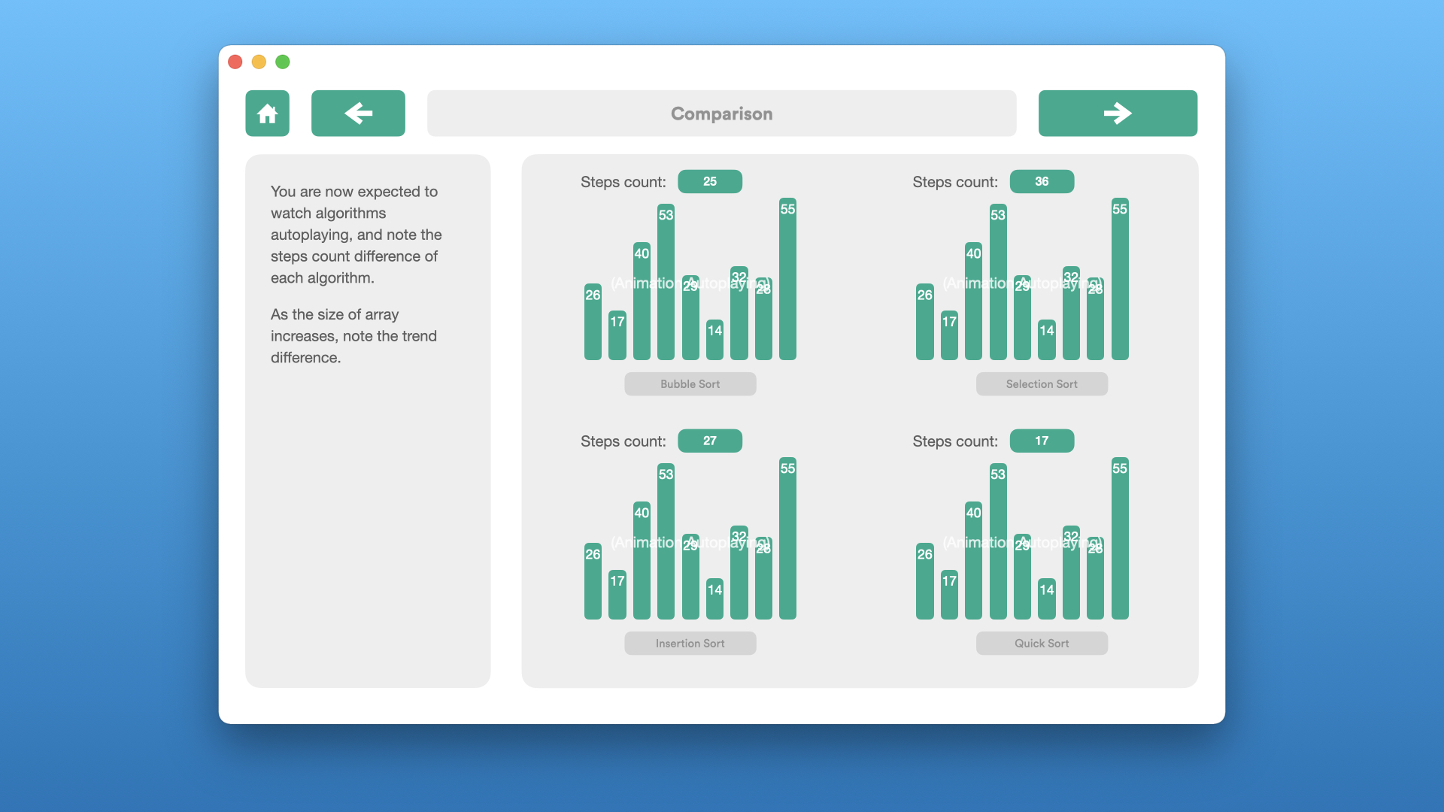

Figure 9. Efficiency - Comparison in low array size

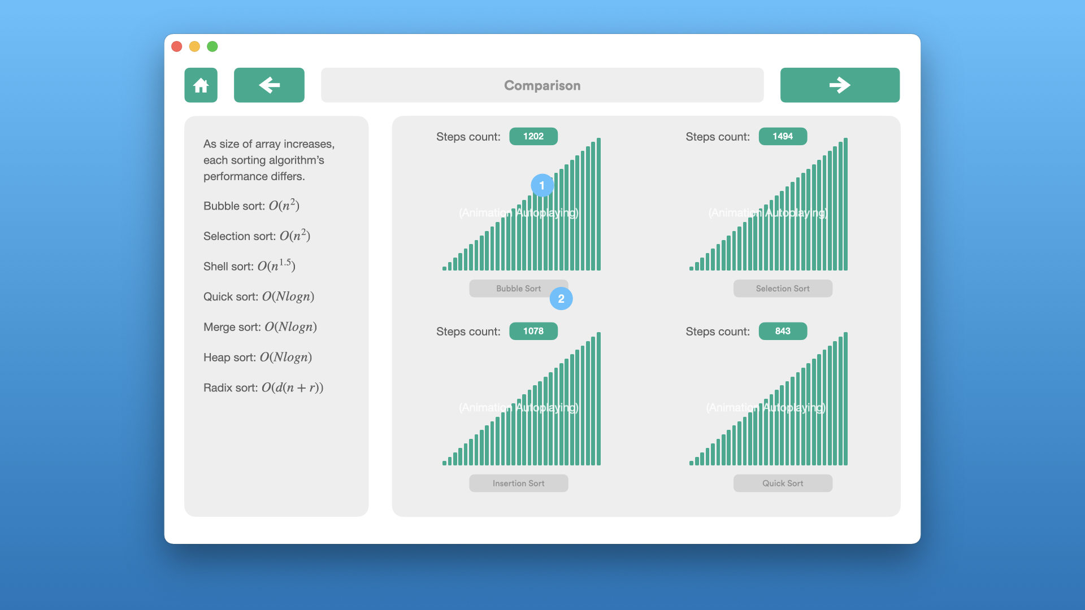

Figure 9. Efficiency - Comparison in high array size

For **Correctness** part, we will firstly give a page introduce the definition of correctness, then provide simplified correctness definition especially for sorting algorithms, designed by us, the algorithm should terminate (no infinite loop) when input is correct, and the output should be strictly sorted. Then the user would enter the main page, select an algorithm to learn. After that, he/she would follow our learning procedure to examine this algorithm in a correctness view.

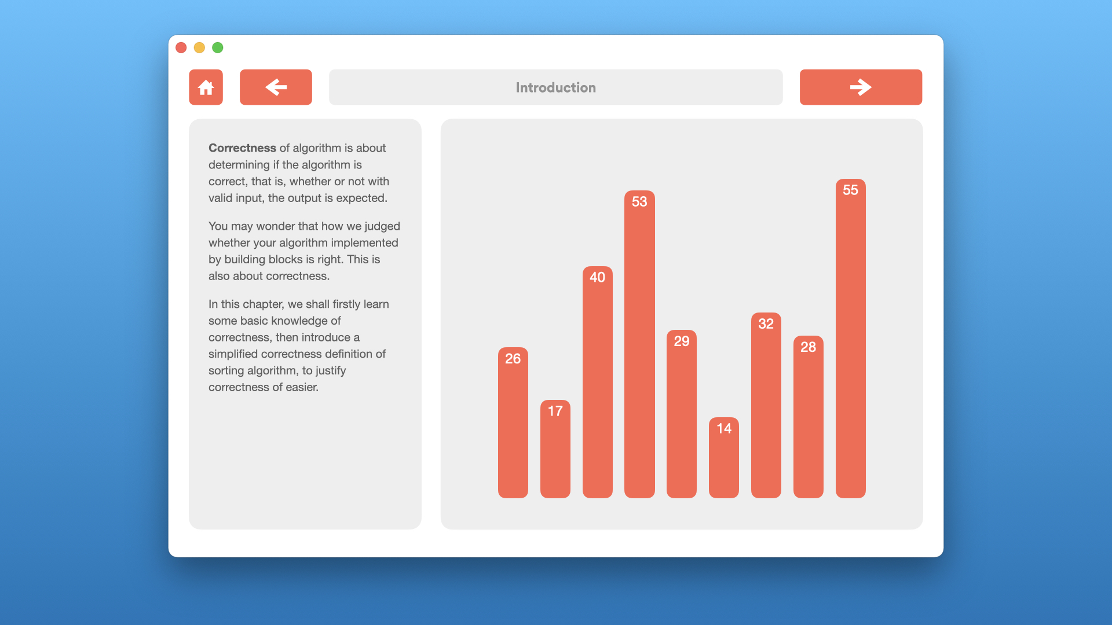

Figure 10. Correctness - Introduction

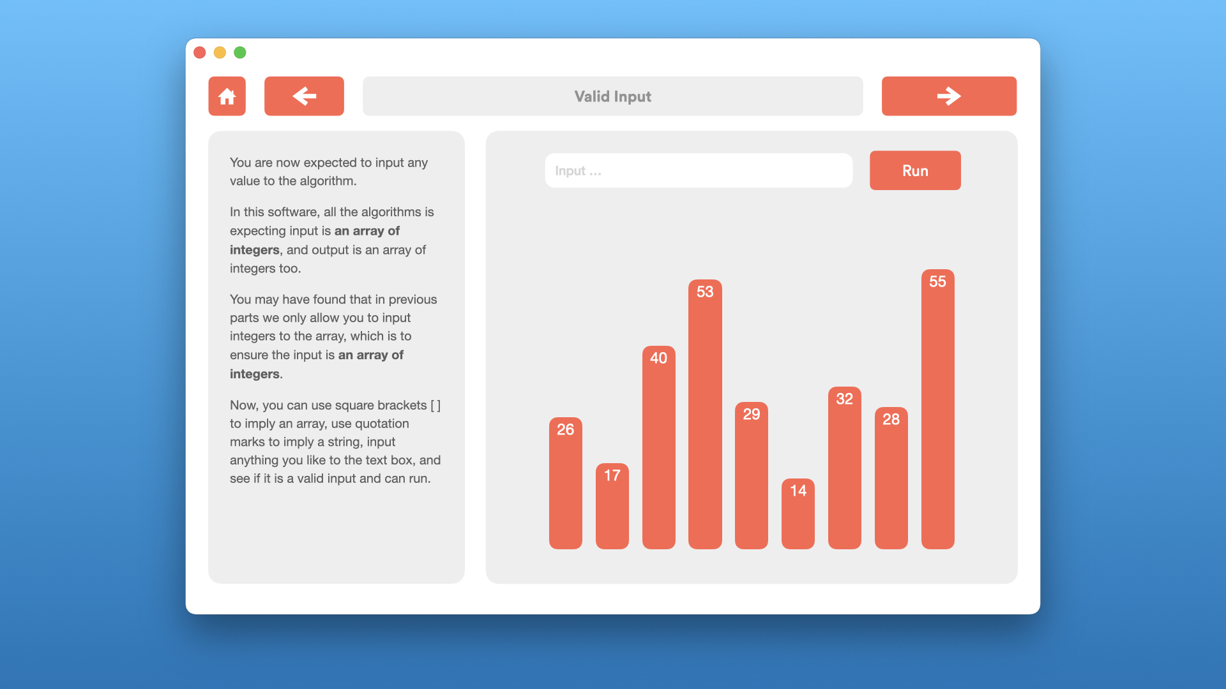

Figure 11. Correctness - Valid Input (other subparts are similar to this figure)

For **Exercise** part, a question bank allows user to choose which aspect of questions to do. It will then generate a set of questions, let the user do in a limited time, and give feedback.

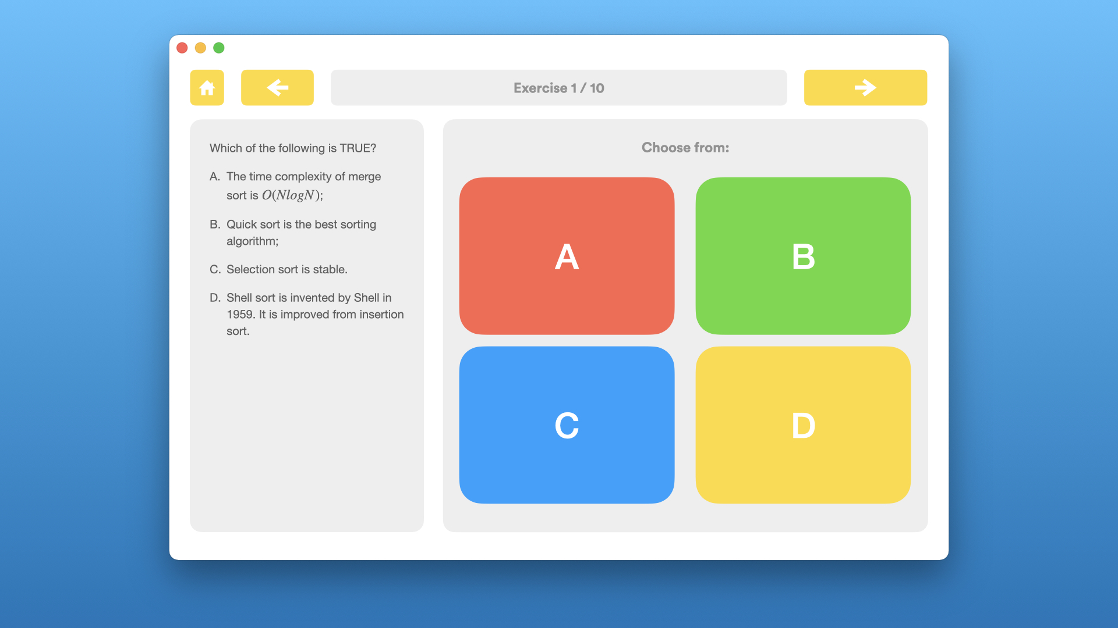

Figure 12. Exercise - Choice Questions